MODERN PERIODIC TABLE

A tabular arrangement of elements in rows and columns, highlighting the regular repetition of properties of the elements, is called a periodic table.

Development of the Periodic Table:

In 1869 the Russian chemist Dmitri Mendeleev (1834–1907) and the German chemist J. Lothar Meyer (1830–1895), working independently, made similar discoveries. They found that when they arranged the elements in order of atomic mass, they could place them in horizontal rows, one row under the other, so that the elements in each vertical column have similar properties.

Eventually, more accurate determinations of atomic masses revealed discrepancies in this ordering of the elements. When the elements in the periodic table are ordered by atomic number, such discrepancies vanish. In 1913, the British physicist Henry Moseley measured the wavelengths of certain X rays emitted by elements. His measurements showed that these wavelengths were related to the atomic numbers of the elements.

In modern version of the periodic table, each entry lists the atomic number, atomic symbol, and atomic mass of an element.

Modern Statement of the Law of Periodicity: ‘The modern periodic law states that the properties of the elements repeat after certain regular intervals when these elements are arranged in order of their increasing atomic numbers’.

The cause of periodicity in properties is the repetition of similar outer electronic configuration after certain regular intervals. Since the nucleus is situated at the center of an atom and is shielded by electrons in the outermost level, therefore, the atomic mass has little effect on the chemical properties of the elements. Electrons are exposed to the environment. Hence, they can interact with other atoms. As a result, the physical and chemical properties of the elements depend upon their atomic numbers rather than the atomic masses.

Main Features of Modern Periodic Table
Modern periodic table is based upon the electronic configuration of the elements. It consists of 18 vertical columns (Groups) and 7 horizontal rows (Periods).

Groups

Elements that have similar chemical properties are grouped in columns called groups. All the members of a Group have the same valence configuration but different principal quantum numbers. These groups are numbered from 1 to 18 in 1988 by IUPAC. The groups are also divided into two sub groups: A and B. These are numbered IA(1), IIA(2), IIIB(3), IVB(4), VB(5), VIB(6), VIIB(7), VIIIB(8,9,10), IB(11), IIB(12), IIIA(13), IVA(14), VA(15), VIA(16), VIIA(17) and VIIIA (0,18) groups.

Group 1 is called alkali metals. They are highly reactive and have a +1 charge. Group 2 is called alkaline earth metals. They have +2 charge. Transition metals are in the middle, they have groups from 3 to 12. The inner transition metals are at the bottom- as lanthanides and actinides. Group 17 is called halogens. They are also highly reactive and have a -1 charge. Group 18 or zero is called the Noble Gases/ Inert Gases.

Hydrogen occupies a unique position at the top of the periodic table. It does not fit naturally into any Group. It has a single positive charge, like the alkali metals, but at room temperature, it is a gas that doesn't act like a metal.

The elements in group VIIIB consist of three groups (8, 9 & 10) of elements at the middle of the periodic table. They contain triads, which are metals with very similar properties, usually found together.

Periods
The period number of an element signifies the highest unexcited energy level for an electron in that element. The period number equals the principal quantum number of the valence shell.
The first period consists of only two elements – Hydrogen and Helium. The 2nd and 3rd period consists of 8 elements each. On the other hand, the 4th and 5th consists of 18 elements each while the 6th and 7th period consists of 32 elements each. A separate panel at the bottom consists of 15 elements of the 6th period called the lanthanides and 15 elements of the 7th period called the actinides.
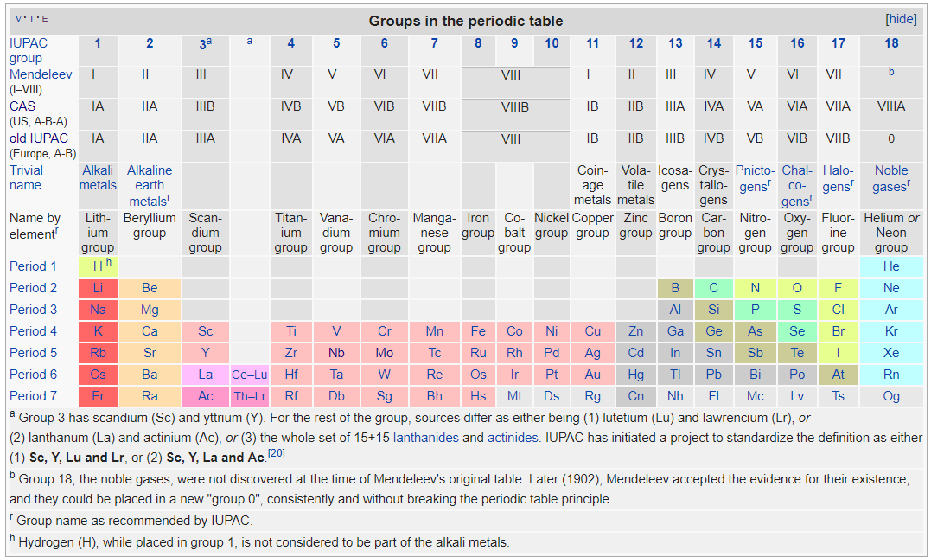

Elements 113, 115, 117 and 118, the most recent discoveries, were officially confirmed by the International Union of Pure and Applied Chemistry (IUPAC) in 2016. Their proposed names, nihonium (Nh), moscovium (Mc), tennessine (Ts) and oganesson (Og) respectively. Lanthanoids (La-Lu) and actinoids (Ac-Lr) are collective names also recommended by IUPAC.
CLASSIFICATION OF ELEMENTS
Classification of the elements into BLOCKS:
The s-block elements have valence configuration s¹ or s².
The p-block elements have valence configuration s²p¹ to s²p⁶.
The d-block elements have valence configurations in which d-subshells are being filled.
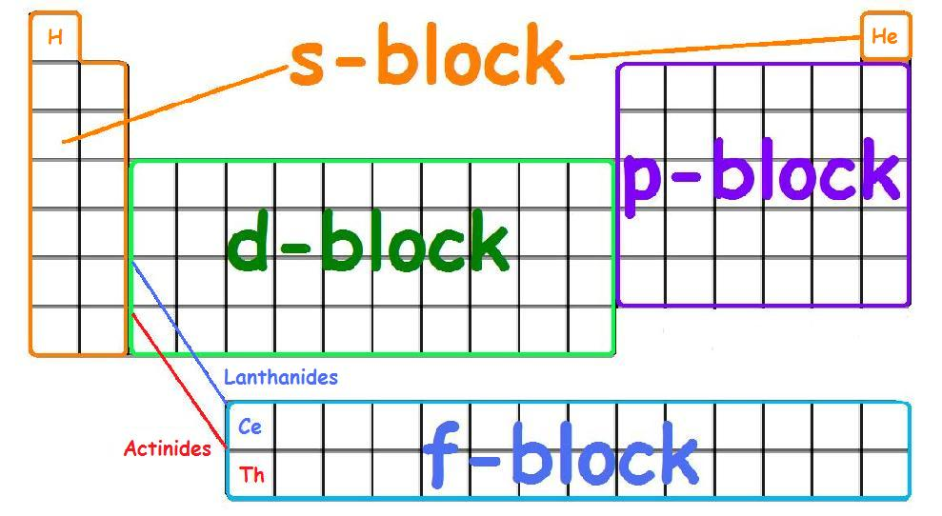
The f-block elements have valence configurations in which f-subshells are being filled.

Classification of elements depending on electronic configuration:
The physical and chemical properties of the elements are largely determined by their electronic structures:
  - The Inert Gases (elements of ‘0’ group)
  - The Representative Elements (‘s’ and ‘p’ block elements)
  - The Transition Elements (‘d’ block elements)
  - The Inner Transition Elements (‘f’ block elements)

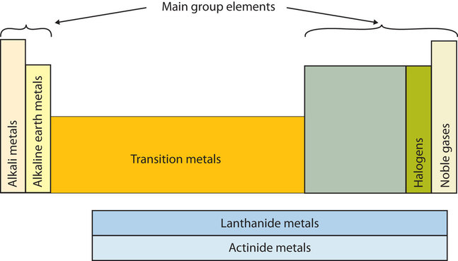

Classification of elements into Metals, Nonmetals and Metalloids:

Metals

Most elements are metals. There are so many metals, they are divided into groups: alkali metals, alkaline earth metals, transition metals and inner transition metals. The inner transition metals can be divided into smaller groups, such as the lanthanides and actinides.

Properties of Metals: Metals share some common properties. They are lustrous (shiny), malleable (can be hammered into sheets) and ductile (can be drawn into wire) and are good conductors of heat and electricity. Except for mercury, the metallic elements are solids at room temperature (about 20⁰C). These properties result from the ability to easily move the electrons in the outer shells of metal atoms.
Alkali Metals: The alkali metals are lithium (Li), sodium (Na), potassium (K), rubidium (Rb), cesium (Cs) and francium (Fr). Hydrogen is unique in that it is generally placed in Group 1, but it is not a metal. The compounds of the alkali metals are common in nature and daily life. One example is table salt (sodium chloride); lithium compounds are used in greases, in batteries, and as drugs to treat patients who exhibit manic-depressive or bipolar behavior. Although lithium, rubidium, and cesium are relatively rare in nature, and francium is so unstable and highly radioactive that it exists in only trace amounts, sodium and potassium are the seventh and eighth most abundant elements in Earth’s crust, respectively. These elements form ions with a +1 charge and have the largest atom sizes of elements in their periods. The alkali metals are highly reactive.
Alkaline Earth Metals: The alkaline earth metals are beryllium (Be), magnesium (Mg), calcium (Ca), strontium (Sr), barium (Ba) and radium (Ra). Beryllium, strontium, and barium are rare, and radium is unstable and highly radioactive. In contrast, calcium and magnesium are the fifth and sixth most abundant elements on Earth, respectively; they are found in huge deposits of limestone and other minerals. They have ions with a +2 charge. Their atoms are smaller than those of the alkali metals.
Transition Metals: The transition elements are in Groups 3 to 12. Iron and gold are examples of transition metals. These elements are very hard, with high melting points and boiling points. The transition metals are good electrical conductors and are very malleable. They show positive oxidation states of +2 and +3 generally and contain two incomplete energy levels (‘s’ & ‘d’ orbitals). They are effective catalytic agents and generally form coloured and complex compounds.
The transition metals include most of the elements, so they can be categorized into smaller groups. The lanthanides and actinides are classes of transition elements. Another way to group transition metals is into triads, which are metals with very similar properties, usually found together.
Metal Triads: The iron triad consists of iron, cobalt, and nickel. Just under iron, cobalt, and nickel is the palladium triad of ruthenium, rhodium, and palladium, while under them is the platinum triad of osmium, iridium, and platinum.
Lanthanides and Actinides: When you look at the periodic table, you'll see there is a block of two rows of elements below the main body of the chart. The top row has atomic numbers following lanthanum. These elements are called the lanthanides (rare earths). The lanthanides are silvery metals that tarnish easily. They are relatively soft metals, with high melting and boiling points. The lanthanides react to form many different compounds. These elements are used in lamps, magnets, lasers, and to improve the properties of other metals.
The actinides are in the row below the lanthanides (trans-uranium). Their atomic numbers follow actinium. All the actinides are radioactive, with positively charged ions. They are reactive metals that form compounds with most nonmetals. The actinides are used in medicines and nuclear devices.
These elements have three incomplete outer levels (‘s’, ‘d’ & ‘f’ orbitals) and their properties are similar to as in the case of transition elements.
Nonmetals & Metalloids
A nonmetal is an element that does not exhibit the characteristics of a metal. Most of the nonmetals are gases (for example, chlorine and oxygen) or solids (for example, phosphorus and sulfur). The solid nonmetals are usually hard, lack metallic luster, brittle substances. Bromine is the only liquid nonmetal. The halogens and the noble gases are two groups of nonmetals.

Metalloids, or semimetals (B, Si, Ge, As, Sb, Te, Bi, Po) are elements having both metallic and nonmetallic properties. These elements, such as silicon (Si) and germanium (Ge), are usually good semiconductors—elements that, when pure, are poor conductors of electricity at room temperature but become moderately good conductors at higher temperatures.
Halogens: Halogens are in Group 17 of the periodic table. The halogens are fluorine (F), chlorine (Cl), bromine (Br), iodine (I) and astatine (At). All the halogens react readily with metals to form compounds (salts), such as sodium chloride and calcium chloride (used in some areas as road salt). Compounds that contain the fluoride ion are added to toothpaste and the water supply to prevent dental cavities. Fluorine is also found in Teflon coatings on kitchen utensils. Although chlorofluorocarbon propellants and refrigerants are believed to lead to the depletion of Earth’s ozone layer and contain both fluorine and chlorine, the latter is responsible for the adverse effect on the ozone layer. Bromine and iodine are less abundant than chlorine, and astatine is so radioactive that it exists in only negligible amounts in nature. These elements are also found in bleaches and disinfectants. These nonmetals form ions with a -1 charge. The halogens are highly reactive.
Noble Gases: The noble gases are helium (He), neon (Ne), argon (Ar), krypton (Kr), xenon (Xe) and radon (Rn). Because the noble gases are composed of only single atoms, they are called monatomic. At room temperature and pressure, they are unreactive gases. Because of their lack of reactivity, for many years they were called inert gases or rare gases. However, the first chemical compounds containing the noble gases were prepared in 1962. Although the noble gases are relatively minor constituents of the atmosphere, natural gas contains substantial amounts of helium. Because of its low reactivity, argon is often used as an unreactive (inert) atmosphere for welding and in light bulbs. The red light emitted by neon in a gas discharge tube is used in neon lights. The noble gases are not reactive. Inactivity of the noble gases is due to- (a) complete pairing of all electrons present, (b) absence of any molecular orbital, (c) stable energy state, (d) very high ionization potential and (e) negligible electron affinities.
Periodic trends in modern periodic table
The periodic table helps predict some properties of the elements compared to each other. Atom size decreases as you move from left to right across the table and increases as you move down a column. Energy required to remove an electron from an atom increases as you move from left to right and decreases as you move down a column. The ability to form a chemical bond increases as you move from left to right and decreases as you move down a column. In general, electron affinity value decreases with the increasing atomic radius because the electrostatic force of attraction decreases between the electron being added and the atomic nucleus. This is due to an increase in the distance between them.
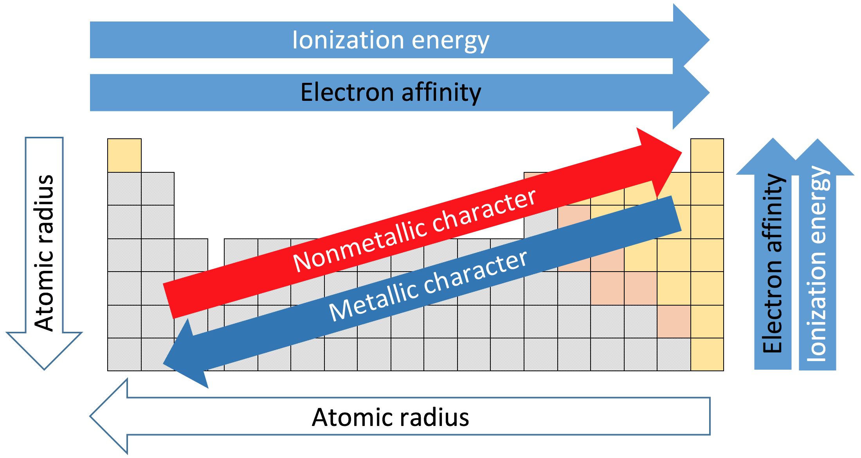

The electronegativity is a measure of the tendency of an atom to attract a bonding pair of electrons towards itself. The electron affinity of an atom or molecule is defined as the amount of energy released or spent when an electron is added to a neutral atom or molecule in the gaseous state to form a negative ion (X + e⁻ → X⁻). The ionization energy is the energy required to remove an electron from a gaseous atom or ion (X + energy → X⁻ + e⁻).

Usefulness & Limitations of the periodic table

Usefulness are- (1) Classification of the elements, (2) Prediction of undiscovered elements, (3) Correction of atomic weight, (4) Periodic table in industrial research etc.

Limitations are- (1) Position of hydrogen, (2) The position of Lanthanides and Actinides, (3) Properties which are not periodic functions, (4) Diagonal relationship etc.

Naturally Occurring and Synthetic Elements
Of the 118 known elements, 94 are found in appreciable quantities in nature. Between hydrogen (H, 1) and uranium (U, 92), only technetium (Tc, 43) and promethium (Pm, 61) are prepared artificially. All trans-uranium elements, those following uranium in the periodic table are synthetic.
Elements are produced artificially in a variety of nuclear transmutation reactions by neutrons or charged particles, including heavy ions. The following are the quantities of trans-uranium elements that have been produced: plutonium (Pu, 94), in tons; neptunium (Np, 93), americium (Am, 95), and curium (Cm, 96), in kilograms; berkelium (Bk, 97), in 100 milligrams; californium (Cf, 98), in grams; and einsteinium (Es, 99), in milligrams. The remaining elements are produced in even smaller quantities.
Distribution of elements on Earth and in Living Systems

Earth’s interior can be divided into- crust, mantle and core. Earth’s crust extends from the surface to a depth of about 40 km. Scientists have been able only to study the crust.
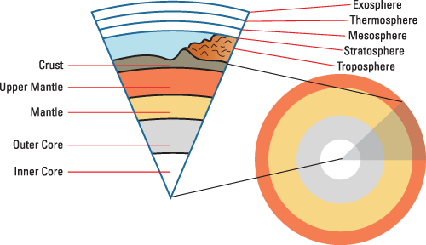

Elements on Earth: Most elements are naturally occuring. Of the 94 elements that are found in nature, 12 make up 99.7% of Earth’s crust by mass. They are (in decreasing order of natural abundance) oxygen (O), silicon (Si), aluminum (Al), iron (Fe), calcium (Ca). magnesium (Mg), sodium (Na), potassium (K), titanium (Ti), hydrogen (H), phosphorus (P), and manganese (Mn). Core consisting mostly of iron at the centre of Earth. Surrounding the core is a layer called mantle, which consists of hot fluid containing iron, carbon, silicon, and sulfur.

Elements in Human Body: The essential trace elements in the human body which make up about 0.1 % of body mass are iron (Fe), copper (Cu), zinc (Zn), iodine (I), and cobalt (Co). These elements are necessary for biological functions such as growth, transport of oxygen for metabolism, and defense against disease. Too much or too little of these elements in our body over an extended period can lead to serious illness, retardation, or even death.
